Started at 14:00 (spent the morning sorting out stuff for Michelle’s trip: train tickets, time with the youngies, etc.)

Worked more on the ITH evaluator. Got the graph working, and it visualises useful data about the spread of resulting values for each group

# Messages to Michelle

So I've made a program that generates graphs based on how ITH's process images. These ones show the results of each image passed through the ITH, and for group that I have defined as "all of the same object/logo" it shows how far apart their trait-values are.

Jordan

So basically I have a collection of ten images of the Dominos sign for example. I then say (with XML, this is why XML is cool!) that all of those images are of "a dominos sign" (which is displayed on the right side of the graphs). A group such as this is then processed by the ITH, and each of the images' values are plotted on a line. The horizontal lines are the groups of images, with the dots being actual values assigned to one such image.

Jordan

This helps me visualize whether or not an ITH is good or useful. If the dots along each horizontal line were spread out more, then the ITH would be too general.

If every group's range was on the left side of the graph for example, that the ITH fails to discriminate one group from another.

The perfect ITH graph would have ranges such that no vertical line running from the top to the bottom of the graph would intersect any of the ranges.



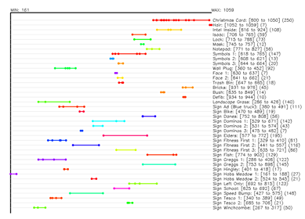

There we go

So that's the graph for the number of white-pixels found in my example earlier.

Which is quite nicely spread out!

The narrower the colored lines, the better.

The more spread out horizontally, there better!

Thanks to this graph generation software, I can see clearly that one of my ITHs is basically pointless

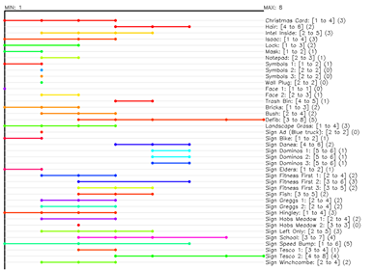

Some of those lines, like the red one in the middle, are way too wide. This ITH measures the color variation across a vertical slice of the image. Kinda confusing? Yeah, it was a quick test, and now I can see it's worth throwing away.

Hopefully that all makes sense 😕

This is huge for me! Only took about two hours to do, but it's perfect for visualizing my progress 😀

Visually speaking, my mission now is to develop ITH's that have real narrow colored lines, and ones that are really spread out horizontally.

This is a pretty good one: it's the ITH that describes the aspect ratio of the subject.

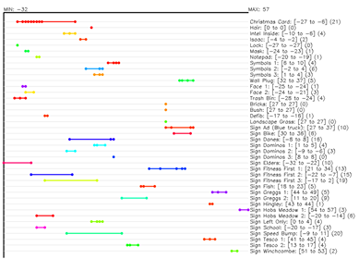

Pretty much all of the lines are narrow, and they're all spread around really nicely.